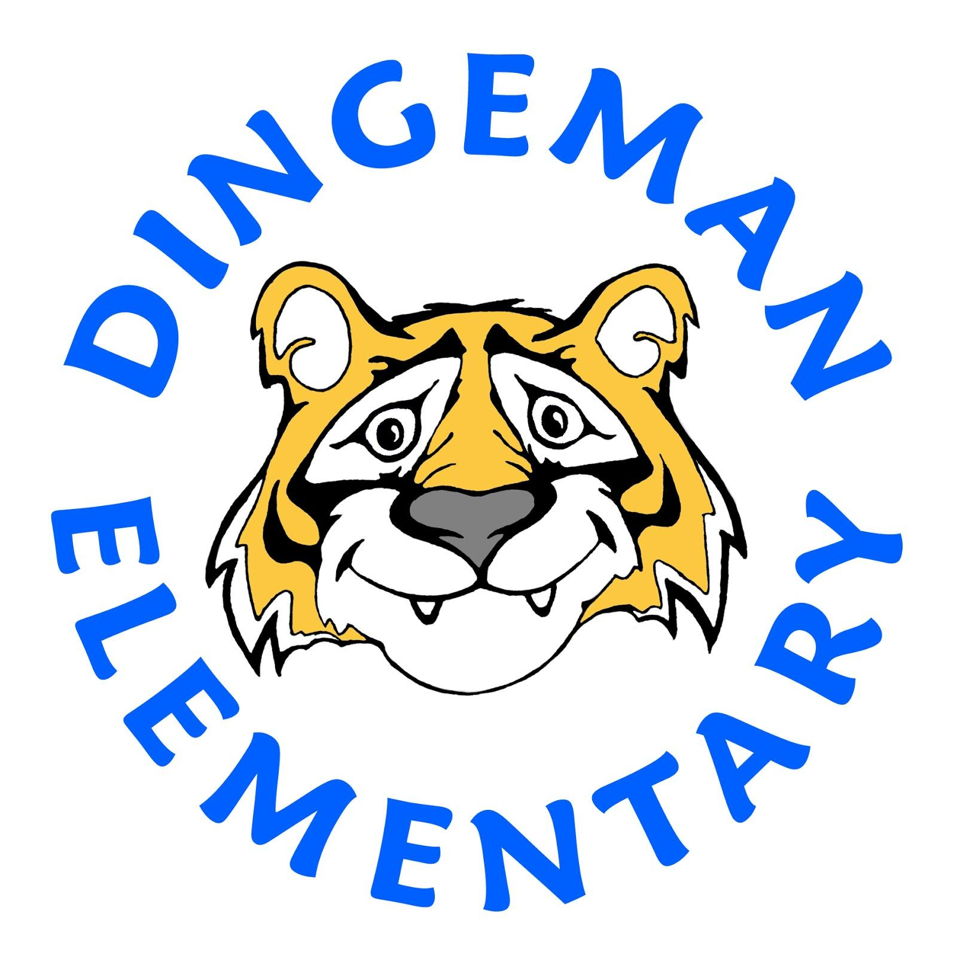Dingeman Elementary Suggested Second Grade Supply List

As a public school, we provide basic school supplies for all students. If you have any of the following items available and want to donate to your child’s second grade class, the items below would be helpful. The following items are suggested materials for your child's classroom use.

Please bring donated items the first week of school
The items below can be purchased at your local stores, however, to make it easier we have provided an Amazon Dingeman Second Grade supply list link.
http://tinyurl.com/dingeman2nd
Remember, by using the Amazon link through Dingeman.net will help support our school.

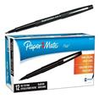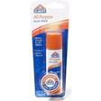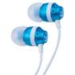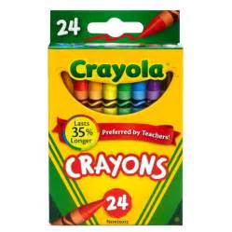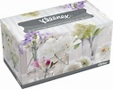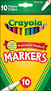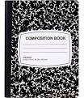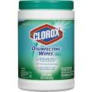

Suggested Supplies For all Second Grade Classes
* 1 Box 10 pack Crayola brand fine tip Classic Markers
* 2-4 Elmer’s Large or Small Glue Sticks
*At least 2 Paper Mate black flair pens
* 1 Pair earbuds (no headphones) Any type will do
* 1 Box of Kleenex
* Box of 24 Crayola Crayons
* 2 Black and White Composition Books 9 ¾ x 7 ½
* Clorox Wipes

